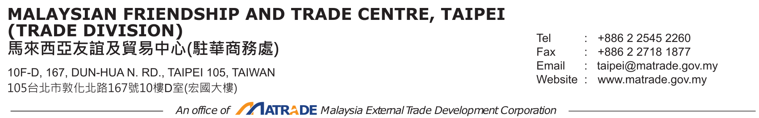

Our Ref：MT/TPE/6/1 Date ：10 April 2026

Dear Sir/Madam,

Invitation to Participate in the International Sourcing Programme (INSP) in conjunction with the 22nd Malaysia International Halal Showcase (MIHAS 2026)
________________________________________________________________________

We, Malaysia External Trade Development Corporation (MATRADE), a national trade promotion agency under the Ministry of Investment, Trade and Industry (MITI), is delighted to invite you to participate as a valued buyer in the INSP in conjunction with MIHAS 2026. As one of the world’s leading Halal trade events, MIHAS brings together a dynamic network of global buyers and suppliers across the entire Halal value chain. This is your opportunity to discover innovative products, connect with trusted & high-quality suppliers and forge strategic partnerships - all within a seamless, one-stop meeting point for global Halal trade.

2. As a buyer, you will benefit from:
- Pre-arranged one-on-one meetings with selected Malaysian suppliers;
- Access to high-quality Halal products and services across multiple sectors;
- Opportunities to diversify sourcing within a large pool of Halal-certified companies, enabling value add segments within your existing offerings; and
- Enhanced supply chain resilience through reliable and competitive sourcing partnerships.

3. Details of INSP@MIHAS 2026 are as follows:
Programme | Date & Venue | Valued Buyers’ Incentives | Deadline for Registration
Physical INSP MIHAS 2026 | 23 September 2026 MITEC, KL | - Complimentary hotel accommodation (4D/3N) per company  - Transport between hotel and MITEC | 25 May 2026
Virtual INSP MIHAS 2026 | 1 April - 30 November 2026  MADANI Digital Trade Platform | - 24/7 meeting arrangement throughout April-November 2026 | 9 Sept 2026

4. Focused sectors include:

- Agricultural Produce | - Information and Communication Technology
- Apparel, Garments and Accessories | - Islamic Content (Film, Drama & Animation)
- Beverages | - Logistics
- Education | - Machinery and Equipment
- Fashion Accessories and Textiles | - Packaging and Containers
- Footwear | - Palm Oil Products
- Franchise | - Pet Products
- Gifts, Souvenirs and Jewelleries | - Pharmaceuticals, Toiletries and Cosmetics
- Gloves | - Prepared Food
- Islamic Financial Services

5. To submit your application, please complete the Registration Form and revert to contact MATRADE Taipei on or before 25 May 2026. More information on MIHAS is viewable at www.mihas.com.my. For further clarification, you may reach out to me by email at norfaizah@matrade.gov.my or taipei@matrade.gov.my, or by phone at 02 2545 2260.

Don’t miss this chance to connect, collaborate and create new growth opportunities - all within a carefully curated and seamless one-on-one meeting experience. We look forward to welcoming you and helping you unlock the full potential of Malaysia’s vibrant Halal market.

Looking forward to your participation at 2026 INSP MIHAS!

Thank you and best regards.

Yours sincerely,

Nor Faizah Ismail (Ms.)
Director of Trade
MATRADE Taipei
2
2

